**Day 6 Assignment.**

1.use ps to search for the “system” process by name.

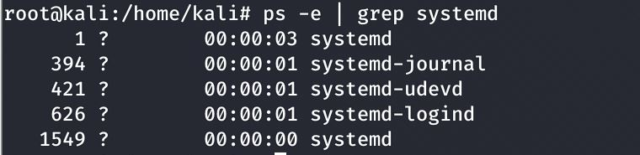

2.find out your terminal name. Using your terminal name, use PS to find all process associated with your terminal



3.Check and note process ID of your shell (from the output of the above command).also note the parents process id of your shell.



4.Start 3 instance of “sleep 123” as background processes.



5.Check and note the process ids of all sleep processes.

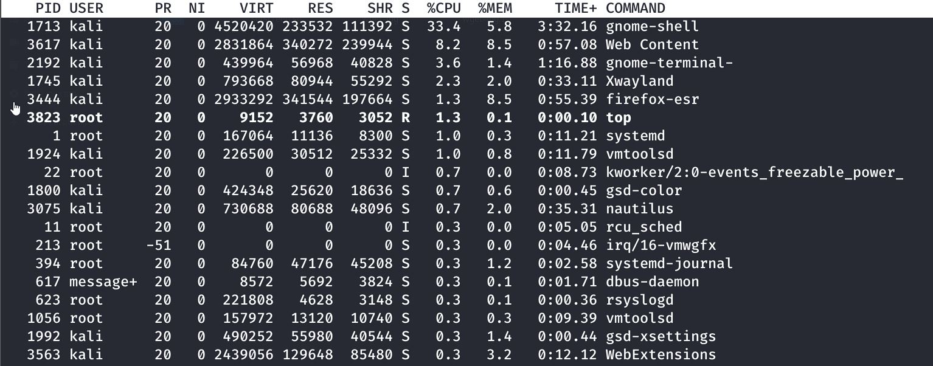

6.Display only those three sleep processes in top. Then quite top

